

# Task 1 – Credit Submission

Student Number: 104071453  
Student Name: MARCO GIACOPPO

### Credit 1a

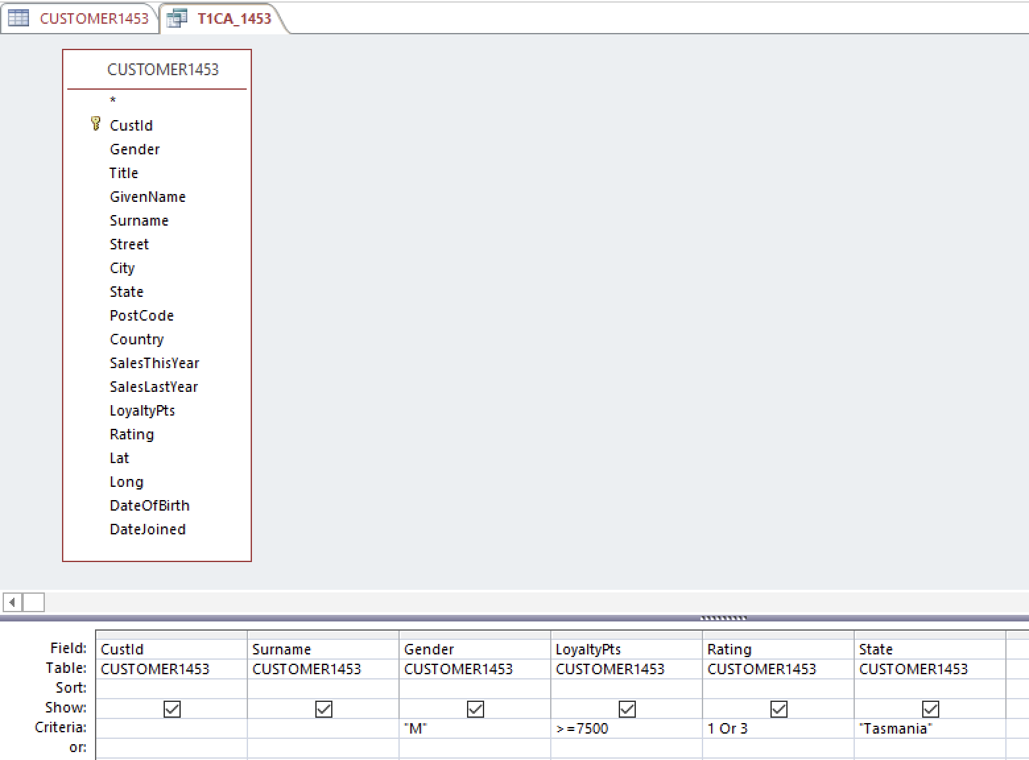

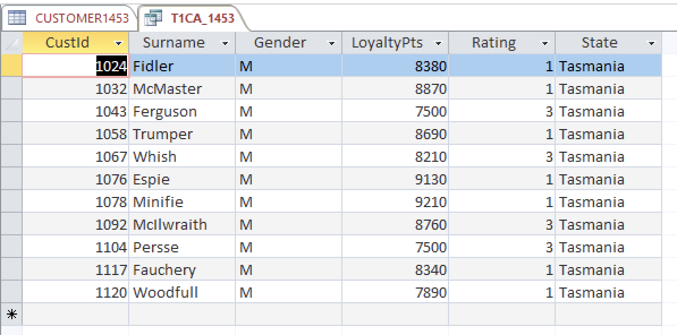

### Credit 1b

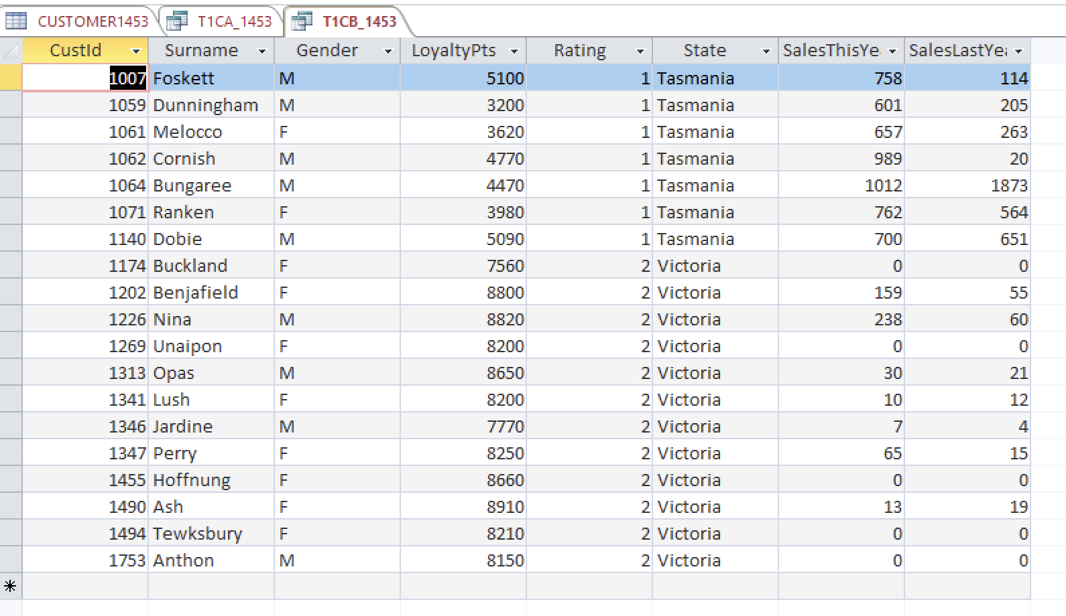

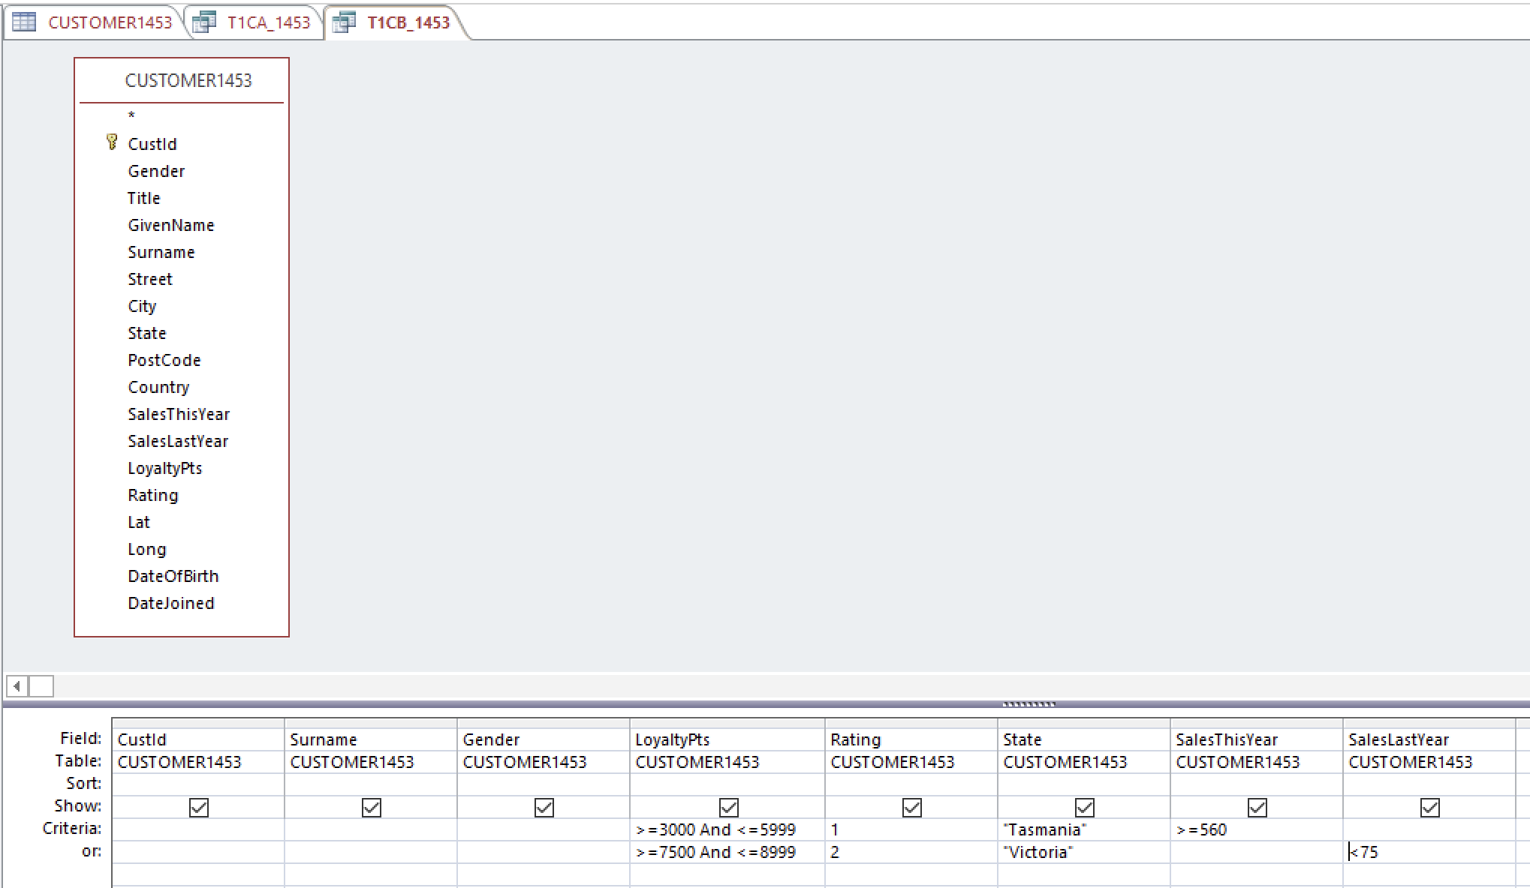

### Credit 1c

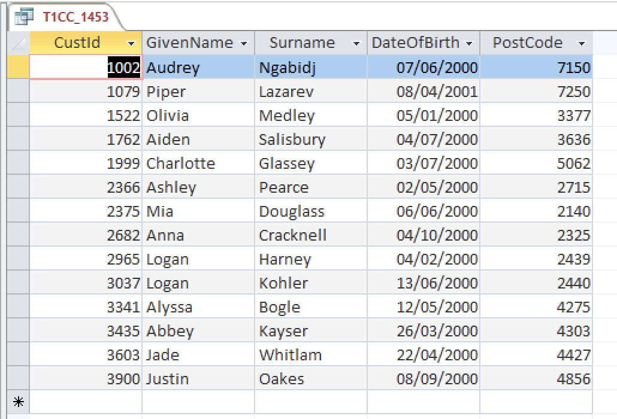

### Credit 1d

### Credit 1e

### Credit 1f

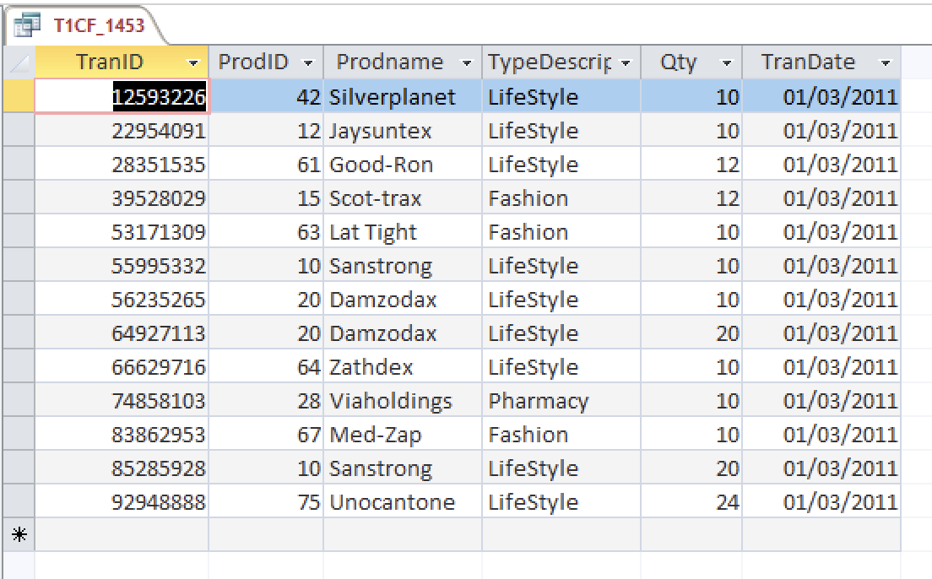

### Credit 1g

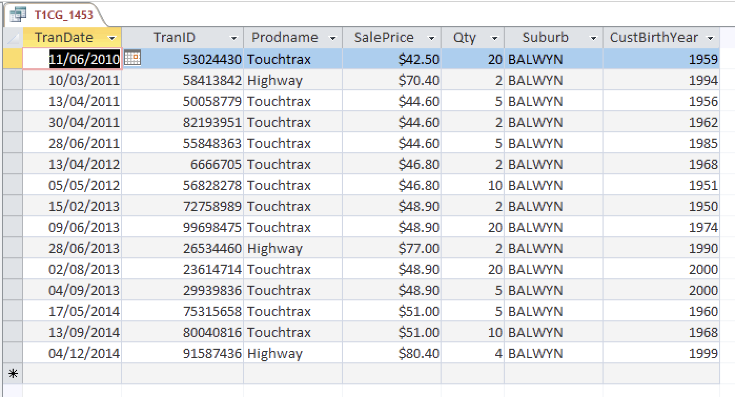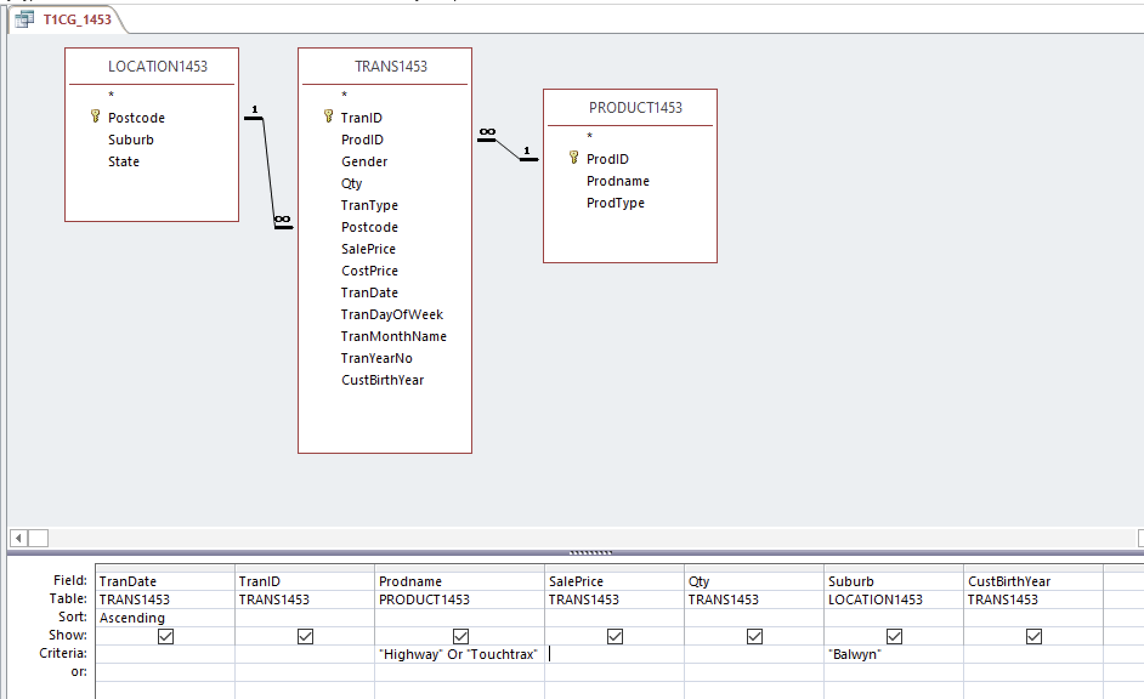

### Credit 1h

Part 1:

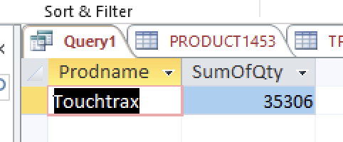

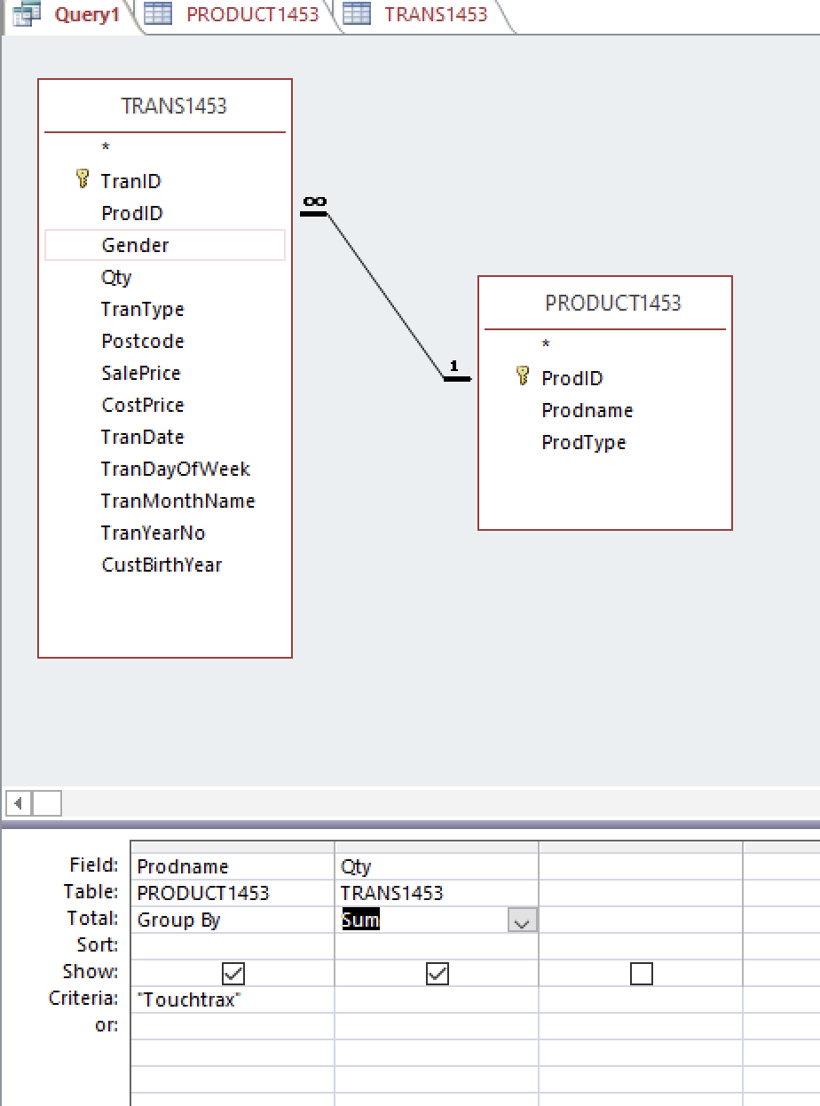

Part 2:

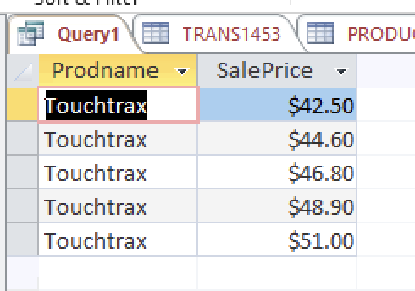

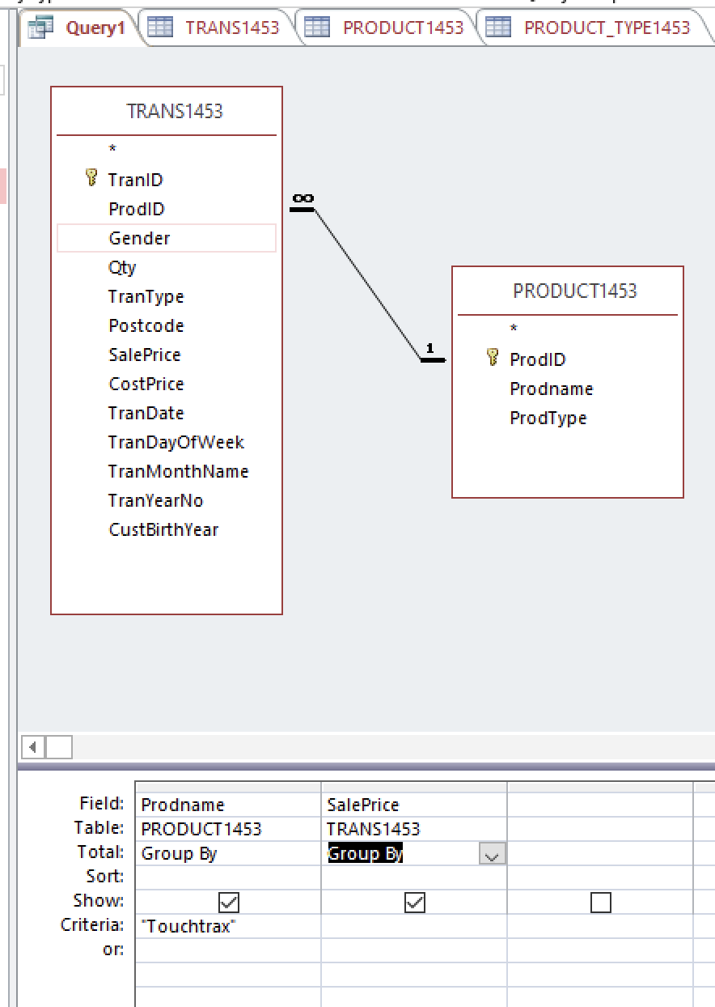

Increasing over the years.

### Credit 1i

### Credit 1j

### 